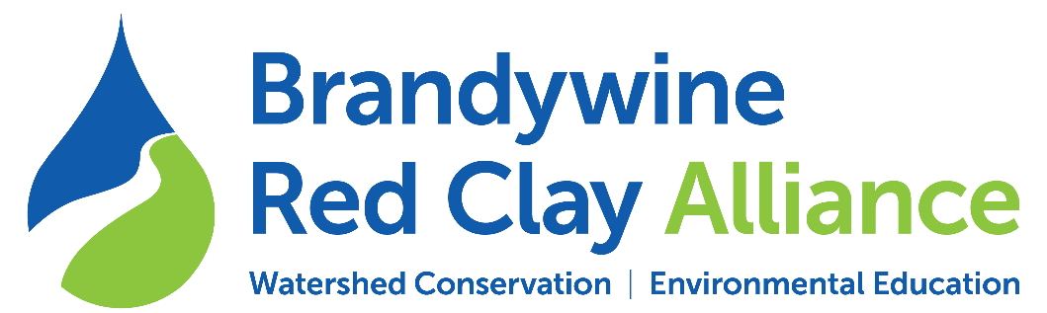
Contact: Brian Winslow
Watershed Conservation Director
bwinslow@brandywineredclay.org
610-793-1090 x103

Red Clay/Nixon Park Stream Restoration
Project Fact Sheet

The Red Streams Blue program was created by BRC in 2008 to ensure that all streams in the Brandywine and Red Clay Watersheds meet Pennsylvania and Delaware water quality standards. One area of focus has been the Upper Red Clay Creek, an impaired stream section in Chester County, Pennsylvania. Thus far we have completed three restoration projects on 4,800 feet of stream working with private land owners and Kennett Square Golf and Country Club (KSGCC). In addition to this project at Anson B. Nixon Park, we have identified another 1,800 feet of stream restoration projects. See map at end of this document for project locations.
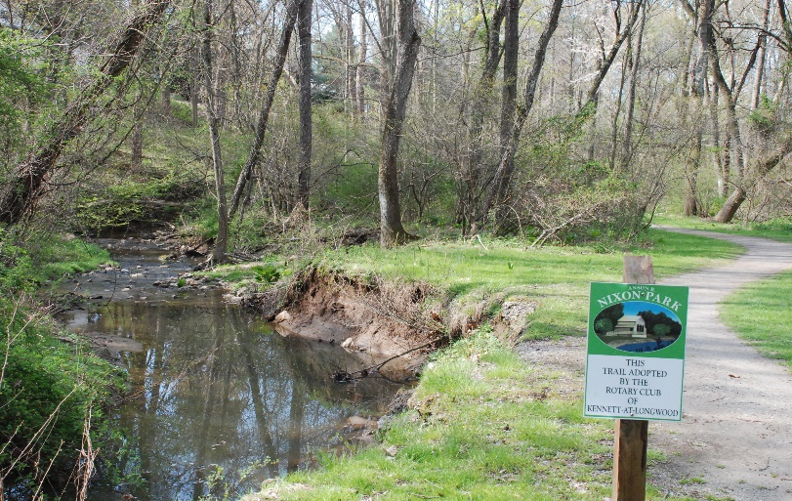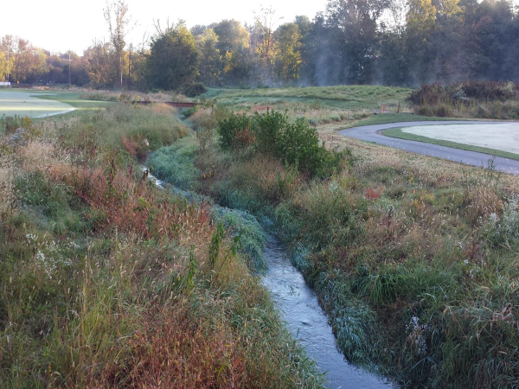
Eroded stream bank threatens trails Restored stream at KSGCC

Project at Nixon Park:

This project will restore 4,400 feet of impaired sections of the main stem and a tributary in the park. The Scope of Work will include re-grading the streambanks to a lower slope and planting the banks with native grasses and wildflowers. In-stream structures such as cross vanes, J-hooks and mud sills will be installed to maintain stream channel integrity and provide bank protection. When the stream channel work is completed, a tree and shrub buffer will be installed where needed with ongoing maintenance provided by the Kennett Area Park Authority staff.

- Benefits of project:
  - Stabilizes eroded stream banks
  - Reduces sediment, phosphorous and nitrogen pollution
  - Helps municipalities meet MS4 Pollution Reduction Plans
  - Improves fish and wildlife habitat
  - Provides aesthetic impact at park
  - Coordinated with park improvement and trail plans

- Working collaboratively with:
  - Kennett Area Park Authority (KAPA)
  - Borough of Kennett Square
  - Kennett Township

- Funding received:
  - $77,500 PADEP Growing Greener Grant for project design
  - $250,000 National Fish and Wildlife Foundation- Delaware Watershed Conservation Fund grant for Phase 1 (US Fish and Wildlife, federal funding)
  - $100,000 Kennett Township (60%) and Borough of Kennett Square (40%)
  - Additional planning support from the William Penn Foundation
  - $215,000 in final funding applications submitted for Phase 2

- Timeline:
  - Construction for Phase 1- Main stem of creek to begin May 11, 2020
  - Construction for Phase 2- Tributary fall/winter 2020/21 pending funding

Stream Restoration Projects on the
East Branch Red Clay Creek
Chester County, PA.

