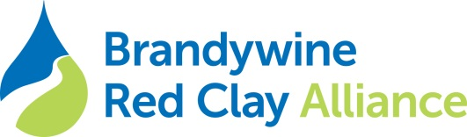
Accountant
Located at the picturesque 300+ acre Myrick Conservation Center in the rolling hills of the Brandywine Valley countryside in southern Chester County, Brandywine Red Clay Alliance has an immediate and rewarding opportunity to make a difference working in the environmental conservation and education field. This position is a regular, part-time opportunity that reports to the Business Director.
Essential Duties and Responsibilities consist of, but are not limited to the following:
Accurately and efficiently perform all Accounts Payable and Accounts Receivable functions.
Process bi-weekly payroll and submit to payroll company.
Record in the General Ledger, payroll and month-end journal entries.
Reconcile financial accounts on a monthly basis in Quick Books.
Provide monthly financial reports.
Calculate and develop financial analysis of the monthly financial reports.
Provide other financial analysis as need.
Assist with the annual budget development.
Assemble information for external auditors for the annual financial audit.
Accurately complete and issue year-end 1099s.
Reconcile the accounting data base and donor data base.
Timely remittance of sales tax.
Maintain an orderly accounting filing system.
Provide support to the Executive Director, Business Director, and Finance Committee.
Other duties as assigned.

Qualifications and Education:
Bachelor’s degree in accounting or business.
Two years of relevant, non-profit accounting experience.
Solid knowledge of accounting basics.
Strong computer, internet, and technology skills with emphasis on Microsoft Office and Excel.
High level of analytical skills and working knowledge of accounting software, especially Quick Books.
Ability to decipher complex data.
Ability to implement direction provided for technical work.
Strong organizational skills and flexibility. Ability to multi-task and manage time to meet frequently changing deadlines.
Ability to deal with confidential information appropriately.
Strong attention to detail and interest in accuracy.

Interested applicants may apply by submitting resume and letter of interest to: EAnderson@BrandywineRedClay.org or Brandywine Red Clay Alliance 1760 Unionville-Wawaset Road, West Chester, PA 19382

